**The E-R model modify to the following:**

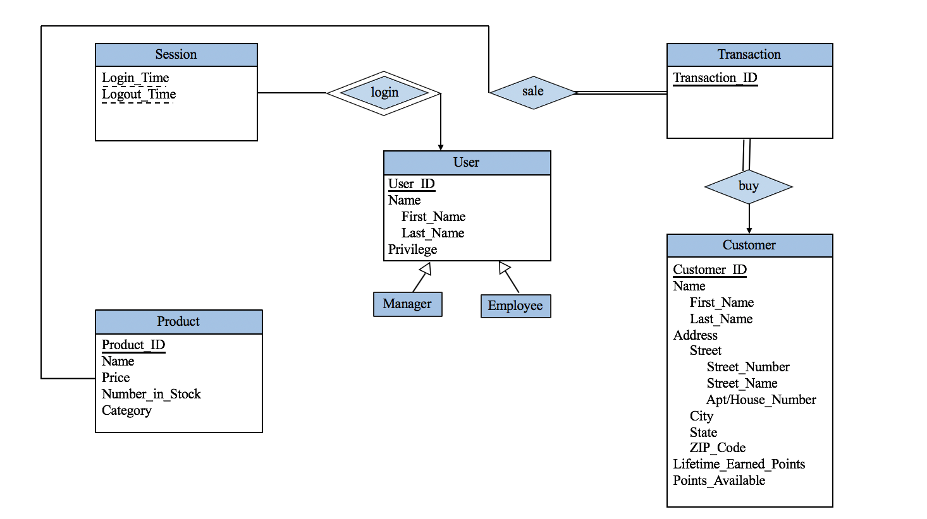

**The relational schema:**

User(User_ID, First_Name, Last_Name, Privilege)

Customer(customer_ID, First_Name, Last_Name, Street, city, state, Lifetime_earned_points, available_points)

Product(Product_ID, Name, Price, Number_in_stock, Category)

Transaction(Transaction_ID, quantity, date, price, Customer_ID, Product_ID)

Session(Login_Time, Logout_Time, User_ID)

The sql command in create_table.txt, Please modify the file name to create_table.sql, and run in the postgresql.